Probabilistic Classification using Naïve Bayes (Gaussian & Multinomial Naïve Bayes)
MULTINOMIAL NAÏVE BAYES - Classify SMS messages as Spam or Ham (Not Spam):
Using Count vectorizer:
Confusion matrix for spam detection:
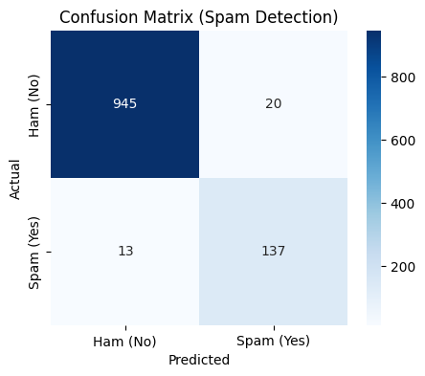
Top 10 words influencing spam classification:
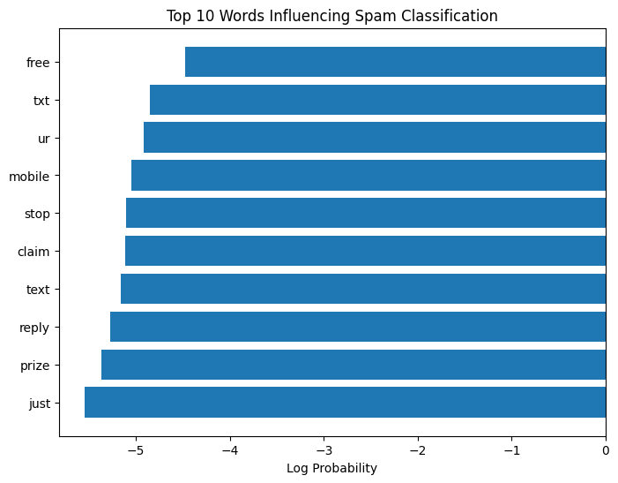
Word frequency comparison:
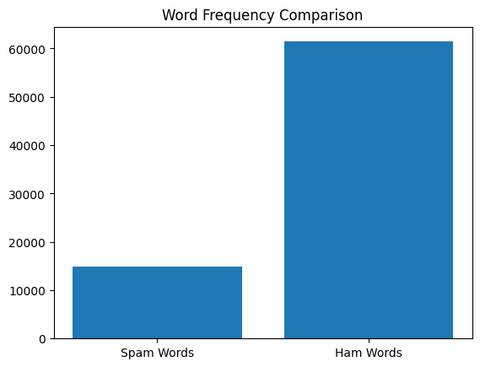
Using TF – IDF method:
Confusion matrix:
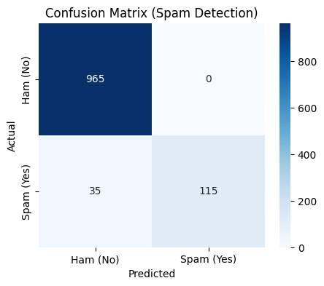
Word frequency comparison:


GAUSSIAN NAÏVE BAYES - Classify flower species based on physical measurements:
Confusion matrix:
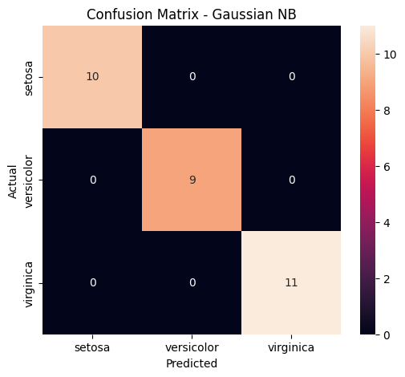
Decision Boundary:
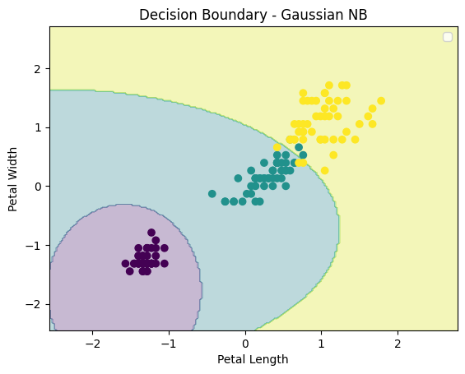
Probability distribution of petal length:
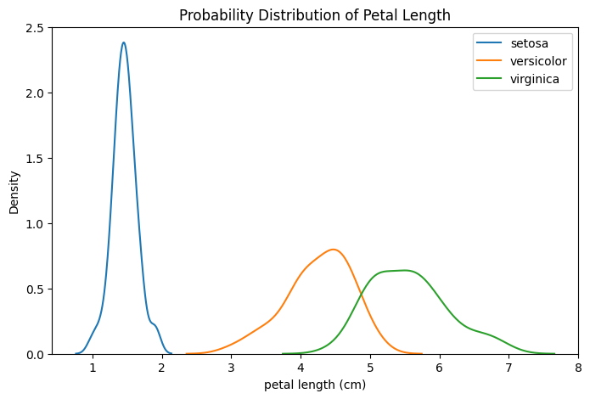
Mean feature comparison:
